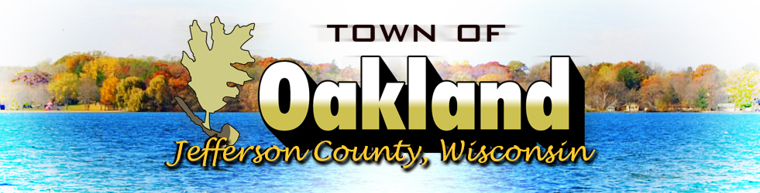
Official Publication

N4450 County Road A
Tuesday June 15, 2021 at 7pm
Town Board Meeting Agenda

***Amended***

- Call meeting to order
- Verification of notice
- Public Comment
- Police Chief’s Report
- Roads Supervisor’s Report
  - Bid for Fence at Town Boat Launch
  - Discussion and possible action regarding the dumpster at the Lake Ripley Boat Launch
- Clerk/Treasurer’s Report
  - Update on Deputy Clerk/Treasurer hiring process
  - Update on ARPA Funds
- Discussion and possible action regarding contract with J&D Pounder and Associates
- Discussion and possible action regarding Liquor Licenses for establishments in Oakland for the period of July 1, 2021 through June 30, 2022
  - Class A Beer, Class B Beer, Class A Liquor & Class B Liquor
    - The Bait Shanty II
    - LR Pizza, Inc (Lake Ripley Lanes)
  - Class A Beer, Class B Beer & Class B Liquor
    - The Sports Page Bar and Grill
    - The Lake Ripley Country Club
    - Oakland Center Tavern
  - Class B Beer and Class B Liquor
    - Jefferson Speedway
    - Hering’s Lake Ripley Inn
    - London Depot (Mink Farm Tavern & Grill)
  - Class B Beer
    - Oakland Conservation Club
- Discussion and possible action regarding Cigarette Licenses for the time period of July 1, 2021 through June 30, 2022
  - Bait Shanty II (N4098 Marina Ln), The Lake Ripley Country Club (W9575 USH 12), Mink Farm Tavern (W9624 USH 12) & Lake Ripley Lanes (W9582 USH 12)
- Discussion and possible action regarding Operator’s Licenses for the time period of July 1, 2021 through June 30, 2022
  - Hering’s Lake Ripley Inn – Kristin Apple, Shelli Blomgren, Amy Bohr, Frances Coy, Hannah Dempsey, Ashley Green, John Hinrichs, Deborah Kulow, April Latsch, Lisa Roedl, & Jean Schroedl
  - Lake Ripley Country Club – Christopher Allen, Brian Bailey, Taylor Bienfang, Steven Borchardt, Samuel Carrig, Sarah Dudnik, Ben Engelstad, Erik Engelstad, Leah Furseth, Drew Jeffery, David Jensen, David Jensen, Julie Mickelson, Margaret Mickelson, Samuel Mickelson, Julie Mickelson, Ann Nottestad, Daniel Peppey, Katelynn Robinson, Nichole Thordson, Hannah Thorson, Debra Wethal, Olivia Williams, Jonathon Zellmer, & Keagen Zibell,
  - J & T Bait Shanty II – Cynthia Dudley, William Zibell, Jessica Holmes & Jennifer Steinhorst
  - Jefferson Speedway – Taylor Ask, Cindra Brody, Jenny Henning, Amanda Kranz, Kelly Mitchell, William Robertson, & Terry Tucker
  - Lake Ripley Lanes – Alton Chia, Calli Dahl, Leah Furseth, Jennifer Grasty, Alexis Hommen, Kodiak Porter, Tobias Probst, Karen Robinson, Garrett Schroedl, & Nichole Thordson
  - Mink Farm Tavern – Julie Ann Anderson, Erin Dorn, Susan Engals, Calli Murphy, Jeremias Probst, Roland Raether, & JoAnn Zimmerman
  - Oakland Center Tavern – Tiffany Laxton & Aubrey Pero
  - Oakland Conservation Club – Thomas Ehrke
  - Sports Page Bar & Grill – Susan Engels, Leah Furseth, Kelli Hetts, & Jesse Johnson
- Correspondence
  - Court Dockets
  - Plan Committee Minutes
  - Fire Commission building committee minutes
- Approval of Disbursements
- Next meeting date July 20, 2021
- Adjournment

Posted June 9th 2021, at Hering’s Lake Ripley Inn, Oakland Town Hall, Cambridge Post Office & on the town’s website (www.oaklandtown.com). Also emailed to the Jefferson Daily Union for publication.

Chris M Astrella, MPA, WCPC
Clerk/Treasurer

